He Is the Vine; We Are the Branches
August 23, 2017

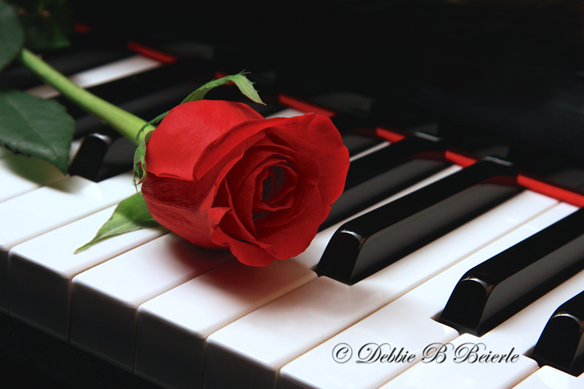
Lord Jesus, You are the vine, we are the branches; without You, we cannot bear fruit. Please, Jesus, show us what abiding in the Vine really means. Amen.

Lately, I’ve been challenged in my choices of what to do with my time. Ministry comes along and that takes precedence over everything. And I have been cutting way back on involvements in the house, as well as giving more time to prayer. But still, I am having major frustrations with music. So, when Jesus approached me tonight to talk, I brought this up.

Lord, I want you more than any skill or thing on this Earth. I love you and cannot live without You. I confess I am a coward, weak, and need your strength to love You and my brothers and sisters. Please, Lord, increase my faith, and my strength. I am such a weakling.

And that prayer came to mind, because I've noticed lately...there's a lazy streak in me. When things look too hard, I don't want to tackle it. And I want to get over that.

But the Lord answered me, and He said, "You are so much Mine."

It is a joy to hear You say that, Jesus.

"It’s true."

I do so want it to be true, Lord.

"But it IS true, Clare. It IS true. You just get a little misguided sometimes. But your heart is for Me and for Me alone."

sigh... I need more time with You, Lord. Please take me at night, to be with You.

"What do you think I am doing now?" He replied.

I have no idea.

"Well, that’s good and we will keep it that way. But you ARE with Me."

OK. What do You want to discuss?

"Your failure with music. Do you want to fail? Do you want to be released from this? Please —think long and think hard, because you are balking and not believing."

Jesus, I am not seeing how I can give You what You deserve first. And what the channel and my family deserve and still do this with music. I don’t see how it can be done. Every day it is something else—and of course, today was a BIG something else. How could I walk away from ministry to hurting souls?

Jesus replied, "You were right to do what you did. You were right to go swimming. You were right to have communion. You were right, right, right. And now, you are right, listening to Me."

That’s what I mean. It is already 3:00 am and the pressure of music is looming—when I know I need to be with You Jesus, more than anything else in this world. So, I'm just taking this time for You. I want to love and honor You, Lord. I want to be with You. How can I put music before any of these things?

He answered, "Without those ‘things’ —your music, our music would be useless. Utterly useless."

So, how does scheduling and timing fit in with all these things?

"I am going to tell you a secret. Do what your heart tells you to do first, and let the music sit with Me."

But don’t I have to apply myself every day?

"That would be nice, but it's not practical. You are right to put these other things first. In many ways this has been a test for you."

Jesus, I am SO, SO frustrated! Time to get everything done seems impossible without sacrificing what is more important, what is most important….

He answered, "I know how you are feeling. I live inside of you, remember? There are no easy answers, but I am asking you, Clare: do you want this gift?"

I thought about it for a moment, and I needed to ask Him
a question. So I said, "May I ask?"

"Certainly."

Do You, Jesus, want this gift for me?

"Yes, unequivocally, YES."

OK… How is this going to happen?

"With faith all things are possible. But you have not answered My question, Do YOU want this gift?”

Well, it is a way to reach souls and bring them closer to You.

"You are already doing that with the messages."

True…You are doing this through me…why would I want another gift to do this job?

He answered, "Because the gift I want to give you through music is more powerful and effective to bring souls into My Heart. It reaches deeper, Clare. It does, it reaches way deeper. And I want to anoint your music, our music, to heal, to inspire, to draw My Bride to Me. I work through the music just as I work through Julie’s music.

"She had to answer this very same question. But she didn’t hesitate. YOU are hesitating."

I have been so frustrated, disappointed, let down…even by myself. I am so glad you brought this up, because I have been tormented by it. Sometimes I wonder if this is just a great big test to see where the value in my life really is. The needs of the flock on the channel. Time with You. Or gains in music…which could become very narcissistic.

"It’s not a test, Clare. It is your destiny… if you want it. That’s what I’m here to discuss with you. Do YOU really want it? That was the meaning of the rhema that said, ‘I want MY DESIRE to become your dream.’

"This other thought of yours that music is only a test of your faithfulness to Me is a lie from the enemy. He is trying to coerce you into believing you can only have one or the other, not both. That is where much of your doubts are coming from. He is doing this to give you a good way out.

"Clare, anyone who wants to become an effective music minister, or even good musician, must go through many trials before they can succeed. And don’t let Satan tell you, you are too old. You have more strength than most women half your age. So, don’t fall for that. It’s a matter of DESIRE, and REALLY wanting something. Do you REALLY DESIRE THIS?

"See? I am having to ask you another time."

Lord, I cannot even imagine giving up on You. If You want this for me, I want it, too.

"Yes. But independent of Me, do you want this gift?"

Lord, I don’t want anything independent of You.

"Oh, you are a hard case!"

You can make me softer?

"Come here, Beloved."

He took me by the right hand and pulled me ever so close to Himself, looking into my eyes with such sincerity, searching my heart, looking for my sincere response.

He said, “I want, with ALL MY HEART, to see you flourish in this gift. It is My will. It is My purpose for your life. I want this done. Will YOU, do this for ME? Just for Me. All the frustration, failures, hard feelings, doubts, fears—all of it. Will you suffer these for Me, Clare?”

Yes, Lord. I will. Oh Lord, please help. I forget to pray and ask for heavenly assistance. And then I grow weak, frustrated, discouraged.

"I will help you, of course, but I cannot do this for you. I cannot take on the difficulties involved in doing this. This is your cross, Beloved. This is something you are carrying for Me, for love of the One who Loves you as no other ever could. For the One Who waits daily to be in your precious presence and experience your sighs of love. For love of the One who finds great joy in your presence and all the little things you do to please Me. Especially putting others first and taking care of the wounded of this world. Oh, how that consoles Me. For love of Me, Clare... will you do this?"

I will.

"Will you give it your all, in good and in bad times?"

Yes, Lord, I will. I will. I will. I love You, Jesus, and there is nothing more I want in this life than to bring You the joy You long for from my life. To bring You the happiness of a job well done for You, out of no other motive than love. I love You.

He answered, "You know words come easy, but action is tough and you are up against some very strong obstacles. Mostly in your mind, inspired by the enemy. That is why you MUST believe in My power to overcome all your enemies. Faith is your ticket to success. Faith and total reliance on Me, even moment by moment.

"When you come up against obstacles, dryness, lack of inspiration, frustrations with fingers and vocal chords—you are not turning to ME immediately and asking for help. This is a fault. You try to gut it out yourself, getting more and more frustrated, when you should have stopped for a moment and come to sit with Me and sincerely asking in faith for Me to help you. You haven’t done this, Clare. And THAT is part of your reason for failed attempts.

"It’s not just a high five, “Lord help!”

“No, it is an abject admission of inability, coming to Me because there is no where else to go. The singing lessons are very valuable, it is bringing out subtleties in your voice that have been lacking. But you cannot afford to grow tired at that or your piano work. You must call on Me to give you strength, perseverance and success with coordination. You have relied too much on yourself. I want you to recognize this."

I have?

"Yes, but you don’t see it. This is partly responsible for your failures. Before you ever set out to boot up your equipment, you need to come to Me in abject poverty, declaring your dependence on Me. And when you hit a blockage, come again and truly seek Me to help you get past it. Truly seek Me. Not a casual, 'Lord, please help.' But a focused desire and request for My help with a sincere admission of your helplessness. This will teach you to keep your eyes on Me, even when things seem impossible.

"You were hoping I would give you a secret to success tonight—and this is it: rely on Me totally, not on yourself. Don’t go into it single handed—on your own—as you have been doing. You have not been relying on Me, but trying to do it without My help. You have cried out to Me for help, and now I am giving you the formula you have been missing."

How could I be so foolish?

"It’s easy to forget you are a mere human when you are facing a super-human project. Just because I asked and anointed you to do it, does not mean you can do it on your own. On the contrary. I always throw you into hot water over your head when you can’t swim—so you will rely on Me alone.

"Try that this week and see if WE don’t make a BIG difference."

